Table of Contents
1. Purpose 2
2. Application Overview 3
3. Test Strategy 4
4. Test Environments 5
5. Process flow 6
5.1 Build Deployment 6
5.2 Functional Test Cycle 6
5.3 Demos 7
5.4 Regression Testing 8
5.5 Failover/Failback Testing 8
5.6 Test Automation Approach 8
5.7 Procedure for managing backlog in quality center (HP ALM) – update this section with latest process/fields/snapshots 10
5.8 Mobile Testing/Testing on Mobile Devices (need to update this section with AHM Streamline view info) 11
6. Test Data Strategy 13
7. Test Cycle Exit Criteria 13
8. Test Cycle Status Reporting & Metrics 13
9. MITAC & AHM Military Testing 13
10. Security Testing 14
11. Performance Testing 14

Purpose
- To define the process and guidelines for testing the Airplane Health Management (AHM) application
- To define the types of testing to perform for each test level which include the following:
  - Build Verification Testing (BVT)
  - Functional Testing (to include Regression testing)
    - Manual testing
    - Automated testing
    - Ad-hoc/Exploratory testing
  - Multiple browser testing
  - Mobile device testing
  - Security testing
  - Load testing

Application Overview
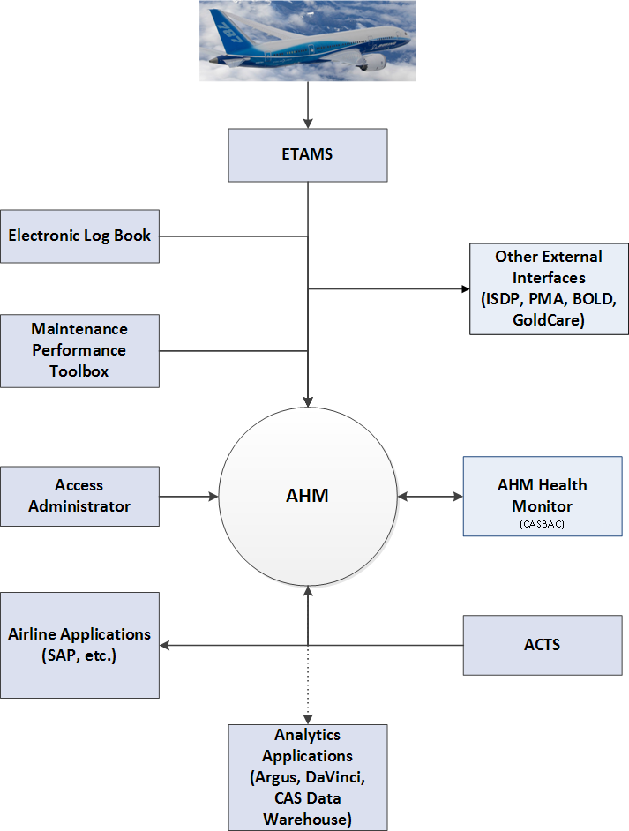

Test Strategy
Digital Aviation IT e-Business focuses on identifying defects as soon as possible and providing for quality throughout the development process to reduce the increased costs associated with discovering defects later in the process. This will be achieved through the adoption of a risk-based test approach with additional focus applied to areas which represent higher impact to AHM users.

The following test types are performed in each sprint or release:
- Unit
- Integrated Functional

The following tests performed after a deployment:
- Build Verification Tests are run every time a build is deployed to an environment (IFT, FREEZE, PROD)
- Regression (only after FREEZE deployment)

The following tests are performed as needed:
- Security
- Load
- Multiple Browsers
- Accessing the AHM web application via mobile devices

Test Environments

 | Intended Use | Data Profile & Currency | Users | Availability
IFT | Build Verification Testing  Integrated Functional Testing  Automated Test Development & Execution  PI System Demos | Production Subset  Subset is current with Production | Feature Team Testers  Automated Test Team | 24x7 with the exception of daily weekday deployments  Support for issues is limited to business hours Pacific time only
BETA | Build Verification Testing  Custom Alert Development & Test  Airline Customer Demo | Production Data  Current with Production | AHS Engineering Team  Customer Ops | 24x7 with the exception of daily weekday deployments  Support for issues is limited to business hours Pacific time only
FRZ | Build Verification Testing  Regression Testing | Production Subset  Subset is current with Production | Feature Team Testers  Automated Test Team  Note: Customer Integrated Environment (CIE) team controls deployments to this environment and requires a SNAP) | 24x7 with the exception of daily weekday deployments  Support for issues is limited to business hours Pacific time only

Process flow

Build Deployment
- Build requests for IFT and BETA should be sent to DL Configuration Management, and all build deployments for those environments will be handled by the CM team.

- Build is deployed to IFT once daily on weekdays, more often by request.

- Build is deployed to Beta once weekly (or as needed)
Note: Only latest build that has been successfully tested on IFT will be deployed onto Beta environment.

- Build is deployed to FRZ once per release by the Operations Team (or as needed to fix an urgent defect).
Note: Deployment to FRZ is dependent on a Go decision in the final test readiness review

Functional Test Cycle
- BVT (Smoke Test) is run after each build deployment.

- Create/update test cases as needed in Quality Center, following the standards to ensure that the test cases are clear and re-useable. Test results are recorded so that test status is measurable and visible (e.g. Mention test data used in Actual result and Expected result section).

Break/Fix Team:
- When an item is ready to be tested on IFT, developers move items into the ‘Ready for Test’ status.
- When a test passes → the tester moves the story/task to ‘Test Complete’ in JIRA.

- When a defect is found:
- Communicate to Developer (code-related) and/or Product Manager (requirement-related).
- Move the item back to ‘In Progress’ status
- After the defect is fixed, run the test case(s) again to verify the fix.
- When creating new test cases for Sustaining AHM:
- Testers:
  - Mark the test case as “Requires Automation Feasibility Review”.
  - Move the test case under the appropriate Feature folder.

- Automation tester:
  - Filter for test case with Automation Status = “Requires Automation Feasibility Review”

  - Review the test case to determine if it’s automatable
    - If yes, mark the test case as “Ready for Automation”
    - If no, mark the test case as “Not Selected for Automation”

  - Once automation is completed, mark the test case(s) as “Automation Complete”

- When updating existing test cases for Sustaining AHM:
- Testers:
  - If the test case has Automation Status = Automation Complete
    - Change the Automation Status to “Automation Update Required”
    - In Comments tab, add info of what was changed (eg. removed step 2, or updated steps 2-5; etc…)

  - If the test case has Automation Status = any state other than Automation Complete
    - Leave the status as-is
    - In Comments tab, add info of what was changed (eg. removed step 2, or updated steps 2-5; etc…)

- Automation tester:
  - Filter for test case with Automation Status = “Requires Automation Feasibility Review”
    - Review the test case to determine if it’s automatable
      - If yes, mark the test case(s) as “Ready for Automation”
      - If no, mark the test case(s) as “Not Selected for Automation”
    - Once automation is completed, mark the test case(s) as “Automation Complete”

  - Filter for test case with Automation Status = “Automation Update Required”
    - Once automation is updated/completed, mark the test case(s) as “Automation Complete”

Release Train Feature Teams:
- Once items are checked out on IFT, developers move items to “QA Ready” in Version One so testers know these are ready for test.

- When a test passed → the tester moves the story/task to “Done” in Version One.

- When a defect is found within the sprint:
- Communicate to Developer (code-related) and/or Business Analyst (requirement-related).
- Submit a subtask (type = software defect)
- After the defect is fixed, run the test case(s) again to verify the fix.

- When a defect is found outside of the current sprint:
- Submit defect in Version One.
- Defect then will go through triage and become a story for future sprint (per Product Owner’s discretion).

- When a new test case is written:
- In Quality Center, place the test case in Test Plan → AHS G3 folder
- Then move the test case to the appropriate folder (by team/sprint) in Test Lab
- In Test Lab, execute the test cases and mark the result accordingly (passed/failed/blocked, etc.)

Demos
- Demos are performed once each sprint or as items complete during a release to make sure that the development meets the Product Owner’s actual requirements.

- The demonstration is done in the IFT environment.

- Only working code which has passed functional testing is demonstrated.

- Product Owners (POs) provide feedback on the development, indicating what meets their requirements and what they would like changed. Requested changes are triaged, including determining whether changes are defects or changed requirements and are entered in JIRA/VersionOne as appropriate.

Regression Testing
- Regression testing occurs once each release. Manual test cases will be complete by testers from the Break/Fix team. Automated test cases will be run by automation team.

- With each release of the code, tests of the new and changed functionality are added to the regression testing library.

- A risk assessment by testers and developers on the Break/Fix team is done based on the code changes made to determine which regression test cases will be executed.

Failover/Failback Testing
- Failover and Failback testing is planned by Operations in response to Production events such as an OS Upgrade, Server Upgrade, or a Severity 1 defect.
- The Test team provides Failover and Failback support by executing an automated BVT when requested.
- The BVT is executed prior to Failover or Failback to confirm health of St. Louis or BLV environment, and Post-Failover to re-confirm health of Production.

Test Automation Approach
In order to reduce time for test execution and increase test coverage and overall quality, AHS has a dedicated Automation Team. The team has created an Automated BVT and is developing a Regression Suite.
Automation of a Build Verification Test has been completed and is executed automatically in Jenkins after each deployment to IFT. The automation team is currently configuring Jenkins to do the same BVT execution after FRZ and PROD deployments. The BVT suite can be run on-demand by a tester for Production deployments and Failover/Failback testing.
Automation of functional tests into a Regression Suite is ongoing. Existing functional test cases are evaluated as potential candidates for automation. These test cases are revised if needed to provide the necessary information for the automation team, then peer reviewed and marked as “Ready for Automation” in Quality Center. An automation tester then automates the test case and adds it to the Regression Suite. The Regression Suite is executed as needed on IFT and FRZ.
The automation team reviews the automated test results and investigates failures. If a failure is the result of a defect in the application, the defect is entered into JIRA and follows the normal triage process. The automation team is responsible for maintaining and updating test scripts.
Developers are responsible for automating their own unit tests.

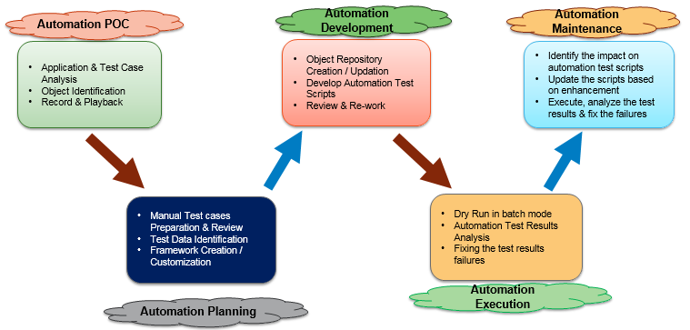

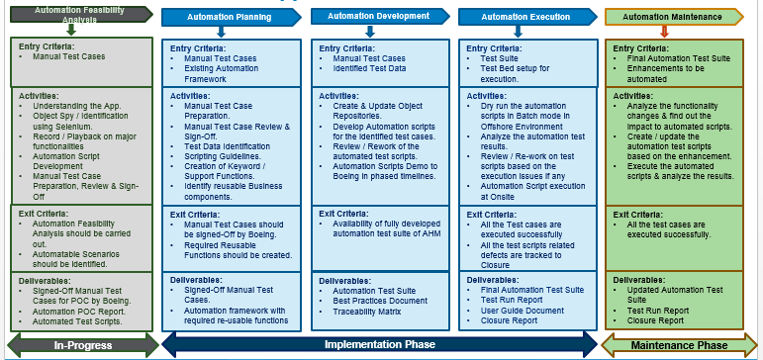

Mobile Testing/Testing on Mobile Devices (need to update this section with AHM Streamline view info)

AHM was not designed with mobile devices in mind, yet customers who have a mobile devices are accessing the AHM web application on these devices via mobile browsers. In order to provide more testing coverage for those devices, a proposal is being developed. A draft of the proposal is below.
- Business to define the scope of testing on mobile devices which includes
  - Which browser type, mobile device type and OS versions to be tested
  - Agreement of Test scope and frequency, that is relevant features or all features or a combination and for which releases
- Evaluate the current web application on mobile browsers and devices for potential use cases.
- Develop in coordination with customers use cases for mobile features.
- Develop AHM Mobile Roadmap and Mobile Strategy based on above items, before Mobile development
In addition, there is a mobile application, AHM Notify, which is being used by XX airlines. The overall mobile strategy must include testing considerations for this and any other mobile application planned for the future.
AHS is considering using an automated testing tool for the relevant devices called Perfecto Mobile. More work is needed to define the details of how this tool will be used and how any required manual testing will be done on these devices.

Mobile Browser/Device List
OS
iPad – Air2 (64 GB) (16 GB is too small for combined testing with Toolbox Mobile in the future)
iPad – mini 4 (64)
iPhone – 6s (16)

Android
8 inch tablet – any brand
Samsung phone (Boeing Std)

Windows 8
Dell Venture (Boeing Std)
Windows phone

Test Data Strategy
Test data for automation such as custom tails, alerts, triggers, and FDE’s are created by the automation team for test case execution on IFT and FRZ.
Manual testers can use existing data on IFT and FRZ, as well as create customized data if needed.
IFT and FRZ have a subset of Production data. Customized data is not normally created on the BETA environment as it is customer-facing.

Test Cycle Exit Criteria

Test Cycle Status Reporting & Metrics

MITAC & AHM Military Testing
The MITAC (Mitsubishi Aircraft Corporation) application and Military projects are developed in the same code base as Classic and G3.
MITAC testing follows the same strategy and release cycle as Classic and G3. Test cases for MITAC are stored Quality Center.
Military testing follows the same strategy as Class and G3, but with a different release cycle and specific resource constraints. A tester for Military must be a U.S. Citizen and cannot be working for a foreign company.
For Military, the Test team validates that the features being developed meet the requirements described in the STD (Software Testing Document). The testing should show traceability – e.g. test cases in Quality Center should be mapped to requirements to verify that all requirements have been met.

Security Testing
AHS uses IBM AppScan, an automated security testing tool, to identify vulnerabilities and monitor application security. AppScan is run once per year. If security issues are identified from an AppScan execution, they are entered as change requests in JIRA and triaged/prioritized to be worked into a current or upcoming release.

Performance Testing

Currently performance testing is done as needed, in response to customer requests or issues observed during testing.

After the migration to Azure the AHS team will redefine performance testing for the new cloud environment. There will be two options:
      - Engage the internal Boeing performance testing group: Performance and Scalability Lab, aka PASL.
      - Engage the automation team to develop and execute performance tests using a standard industry tool such as JMeter.

A Performance Test Plan incorporating Azure servers and one of the options above is expected to be completed in the first quarter of 2017. The goal is to have defined performance requirements and sets of repeatable tests.

